**INFO7250 Engineering Big Data Systems : Team-1**

**Final Project Report**



**Authors**

Ayushi Srivastava, Gaurav Saxena, Ila Nigam, Ruchi D Gupta

Date: 12 December 2016

Version 1.0

Revision History

| Date | Version | Description | Author |
| --- | --- | --- | --- |
| 12/04/2016 | 0.1 | Draft Version | Gaurav Saxena, Ayushi Srivastava |
| 12/05/2016 | 0.2 | Added/ Amended topics: Problem Statement, Description, Work Assignments | Ila Nigam, Gaurav Saxena |
| 12/06/2016 | 0.3 | Added/ Amended topics: Map Reduce Job For combining Amazon Dataset and Omdb API and Average Score calculation. | Ila Nigam, Ruchi Gupta |
| 12/08/2016 | 0.4 | Added/Amended topics: Recommender and Added Pig Scripts | Gaurav Saxena, Ruchi Gupta, Ayushi Srivastava |
| 12/11/2016 | 1.0 | Added/ Amended topics: Web Application, Data Analytics information and Visualization. | Ayushi Srivastava, Gaurav Saxena, Ruchi Gupta, Ila Nigam |

Table of Contents

1. **Team Members**
2. **Problem Statement/Objective**
3. **Approach To Problem**
4. **Introduction to Application**
5. **Work by Each Individual**
6. **Research and findings**
7. **Implementation Details**
8. **Issues and their Resolution**
9. **Conclusion/Results**
10. **Future Scope**

**Team Members**

**Ayushi Srivastava**

**Gaurav Saxena**

**Ila Nigam**

**Ruchi Gupta**

**Problem Statement/Objectives**

The main objective is to build an application that is used to analyze the Amazon movie dataset and IMDB movies that can be used to recommend the users based on the other users ratings and reviews. Application should also provide visualizations to the users as per the various categories and genres. Application should use map reduce algorithm to handle and analyze data that can be used to recommend the Users movies based on various categories and attributes. Application is also capable to handle and perform the user reviews data to do sentiment analysis of the movies. The Application should use other tools from apache Hadoop stack like Pig and hive to perform data Analytics.

**Approach To Problem**

Our project is based on the Amazon Movie Reviews big dataset of size approx. 9 GB. The problem for this dataset is that we need to parse this dataset first for using it for movie recommendation. This is not easy for normal java or python application to handle the large dataset effectively. That why we use Map reduce Algorithm for handling the big dataset and then we need to connect the OMDB API for the matching movies where we need to retrieve the ratings. We need to retrieve the title and fetch the data of the OMDB Application from the title by appending and generating a custom Uri and call the API. Now after retrieving all the values the data is processed and cleaned to retrieve useful information for prediction and recommendation.

**Introduction to Application**

The important functionalities of the application include:

* Analyze the data from the Amazon Movie review dataset and OMDB movie API.
* Analyze the dataset for recommendations based on user and other categories.
* The other Apache’s tool PIG and Hive is used to clean and analyze the data.
* Tableau server is used to visualize the data and show the top movies under many categories.
* Application is used to predict the movie based on the ratings.
* Sentiment Analysis based on the Amazon Movie reviews.

Our project focuses on analyzing Amazon Movie Review Dataset. We have successfully implemented all the tasks mentioned in the project proposal. Our first task was to create a web-based application and use the Amazon’s Movie review dataset and parse the attributes and movie scores for analysis. Then our task was to enhance the number of features by combining the results returned from Amazon Product Advertising API and OMDB API. We took ratings and average scores from both of the applications and used it for data analytics like recommender system, Tableau data Visualization of top movies under categories, genre and movie ratings predictions from Microsoft Azure. We used pig to store and retrieve data as per the requirements. However, since we had developed a user interface, we could not afford to make the user wait for a long time to get the results based on his/her selection on the front-end. Therefore, we went ahead with a persistent data storage using MySQL, which was very responsive from the front end in order to improve the user experience

**Data**

We used the Amazon Movie Review dataset. We obtained the dataset from the

following link: https://snap.stanford.edu/data/web-Movies.html

This dataset consists of movie reviews from Amazon. The data span a period of more than 10 years, including all ~8 million reviews up to October 2012. The reviews include product and user information, ratings, and a plaintext review. Following statistics have been provided for this dataset.

**Dataset statistics:**

**Number of reviews:** 7,911,684

**Number of users:** 889,176

**Number of products:** 253,059

**Users with > 50 reviews:** 16,341

**Median no. of words per review:** 101

**Timespan:** Aug 1997 - Oct 2012

**File Description**

**movies.txt.gz Size:** 9.3GBAmazon movie data (~8 million reviews)

**Dataset Format:**

The Amazon movie review dataset is provided in movies.txt.gz file in the following text format:

**product/productId:** B00006HAXW

**review/userId:** A1RSDE90N6RSZF

**review/profileName:** Joseph M. Kotow

**review/helpfulness:** 9/9

**review/score:** 5.0

**review/time:** 1042502400

**review/summary:** Pittsburgh - Home of the OLDIES

**review/text:** I have all of the doo wop DVD's and this one is as good or better than the 1st ones.

Taking the advantage of parallelism in MapReduce, we queried the Amazon Product Advertising API using the product id information from the JSON file to get the title information for the corresponding product id from the existing dataset. The data returned by the Amazon API was in the following format:

<Item>

<ASIN>B000A2XB9U</ASIN>

<ItemAttributes>

<Director> James Cameron </Director>

<EAN>0014381273229</EAN>

<Format>Color</Format>

<Language>

<Name>English</Name>

<Type>Original Language</Type>

</Language>

<ListPrice>

<CurrencyCode>USD</CurrencyCode>

<FormattedPrice>$19.99</FormattedPrice>

</ListPrice>

<NumberOfItems>1</NumberOfItems>

<ProductGroup>DVD</ProductGroup>

CS6240: Parallel Data Processing in MapReduce

<ReleaseDate>2009-12-18-</ReleaseDate>

<Studio>Image Entertainment</Studio>

<Title>Avatar</Title>

</ItemAttributes>

</Item>

**IMDB Dataset from OMDB API**

Using the same advantage of parallel processing, based on the Title field obtained by parsing the above XML, the OMDB API was hit to get the information about the movie/video like the Genre, Awards, IMDB rating, Language, Year etc. These fields are necessary for the third task in the web application, which was fetching the records based on user input.

<https://www.omdbapi.com/>

Then after retrieving all the movie details, we parse and filtered the movie data for further processing and analysis like movie recommendation, Sentiment Analysis, Visualization and movie rating predictions.

**Implementation Details**

Our first task was to create a web-based application and use the Amazon’s Movie review dataset and parse the attributes and movie scores for analysis. Then our task was to enhance the number of features by combining the results returned from Amazon Product Advertising API and OMDB API.

Next, after cleaning the dataset we tried to recommend the movies based on the user ratings using the Mahout library for machine learning and we got the output file having user based recommendations. Now as it only provides the user based recommendations using ratings, we need to analyze the dataset more and come up with our own implementation of the recommender job using the user and Item based collaborative filtering and Jaccard similarity.

Recommender System:

1. Content based algorithms:

* Idea: If you like an item then you will also like a “similar” item
* Based on similarity of the items being recommended
* It generally works well when it’s easy to determine the context/properties of each item. For instance when we are recommending the same kind of item like a movie recommendation or song recommendation.

2. Collaborative filtering algorithms:

* Idea: If a person A likes item 1, 2, 3 and B like 2, 3, 4 then they have similar interests and A should like item 4 and B should like item 1.
* This algorithm is entirely based on the past behavior and not on the context. This makes it one of the most commonly used algorithms as it is not dependent on any additional information.
* For instance: product recommendations by e-commerce player like Amazon and merchant recommendations by banks like American Express.
* Further, there are several types of collaborative filtering algorithms :

1. User-User Collaborative filtering: Here we find look alike customers (based on similarity) and offer products which first customer’s look alike has chosen in past. This algorithm is very effective but takes a lot of time and resources. It requires computing every customer pair information which takes time. Therefore, for big base platforms, this algorithm is hard to implement without a very strong parallelizable system.

2. Item-Item Collaborative filtering: It is quite similar to previous algorithm, but instead of finding customer look alike, we try finding item look alike. Once we have item look alike matrix, we can easily recommend alike items to customer who have purchased any item from the store. This algorithm is far less resource consuming than user-user collaborative filtering. Hence, for a new customer the algorithm takes far lesser time than user-user collaborates as we don’t need all similarity scores between customers. And with fixed number of products, product-product look alike matrix is fixed over time.

3. Other simpler algorithms: There are other approaches like market basket analysis, which generally do not have high predictive power than the algorithms described above.

**Calculating Similarity:**

Distance between categorical data points

Since we have no ordering between categorical values, we can only measure whether the categorical values are the same or not. Basically we are measuring the degree that attributes values overlap. Hamming distance can be used to measure how many attributes must be changed in order to match one another. We can calculate the ratio to determine the similarity (or difference) between two data points using the simple matching coefficient:

**NoOfMatchAttributes / noOfAttributes**

However, in some cases, equality of certain values doesn’t mean anything. For example, let's say the data point represents a user with attributes representing each movie. The data point contains a high dimensional binary value indicating that the user has or has not seen the movie (1 represent yes and 0 represent no). Given that most users only see a small portion of all movies, if both users haven't seen a particular movie (a value of 0 for both), it doesn't indicate a similarity between the users. On the other hand, if both users saw the same movie (a value of 1 for each), it is implied that the users have many similarities. In this case, equality of 1 should carry a much higher weight than equality of 0. This leads to the Jaccard similarity, as seen here:

**noOfOnesInBoth / (noOfOnesInA + noOfOnesInB - noOfOnesInAandB)**

Whether or not values are matching, though, if the category is structured as a Tree hierarchy, then the distance between the two categories can be quantified by the path length of their common parent. For example, "/product/spot/ballgame/basketball" is closer to "/product/spot/ballgame/soccer/shoes" than "/product/luxury/handbags" because the common parent has a longer path.

**Distance between mixed categorical and numeric data points**

When the data point contains a mixture of numeric and categorical attributes, we can calculate the distance of each group and then treat each measure of distance as a separate dimension (numeric value).

**distancefinal = α.distancenumeric + (1- α).distancecategorical**

**Screenshots and Functionality of the Recommender**

Jobs are divided in five parts:

Users Rating Based Similarity Calculation:

Idea: For every user calculate the movie similarity but only between the movies watched by a user and not with all movies.

a) Preprocessing jobs:

i) Initial Job: Filter out the users ratings data which match the data of all movies data.

ii) Job0: For every user parse the records from Amazon all movies reviews and get data in following format:

Output: user1 movie1; rating; total records for this movie

ii) Job1: For every user make the cross product of the movies in this format:

Output: movie1, movie2; rating1, rating2; total reviews1, total reviews2;

b) Similarity Calculation job:

i) Job2: Calculates the movies similarity using numerical distance calculation:

Output: movie1, Movie2: similarity Score;

2. **Movies Attributes Based Similarity Calculation:**

Idea: For every movie calculate the similar movies:

a) Preprocessing jobs:

i) Job3: Takes the input of all the movies and make the cross product of all the movies in this format:

Output: movie1,movie2 ; m1.attrib1, m2.attrib1; m1.attrib2, m2.attrib2; m1.attrib3, m2.attrib3; ..etc

ii) Job4: For every key-value pair find the difference between the attributes and provide the output :

Output: movie1, movie2 :similarityScore;

3. Merge Similarity job:

i)Job5: Calculates the average of similarity from previous two jobs output

Output: movie1, movie2 :similarityScore;

4. Find Similar Movies:

i)Job6: Finds top 10 movies with highest similarity score for every movie.

Output: movie# movie1:similarityScore; movie2:similarityScore; movie3:similarityScore; etc…

5) Recommend Movies to user:

i)Job7: Finds top 10 movies with highest similarity score for movies watched by user.

• Find all movies watched by user

• For every movie find similar movies and weight it with the rating user gave to the movie.

• Finds top 10 movies with highest similarity score

Output: user : movie1:similarityScore; movie2:similarityScore; movie3:similarityScore; etc…

**InputFileGenerator**

As for recommendation, we are using both Amazon movie review dataset and OMDB API dataset and used the ratings and scores for these two applications to recommend the movies to users.

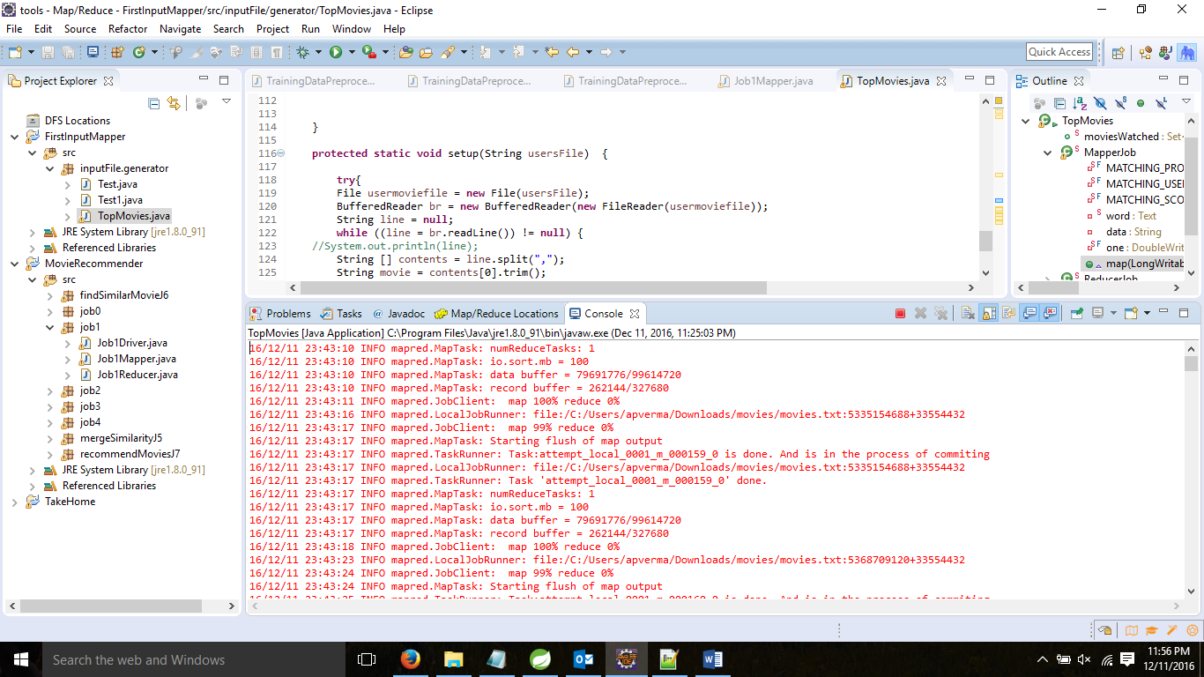

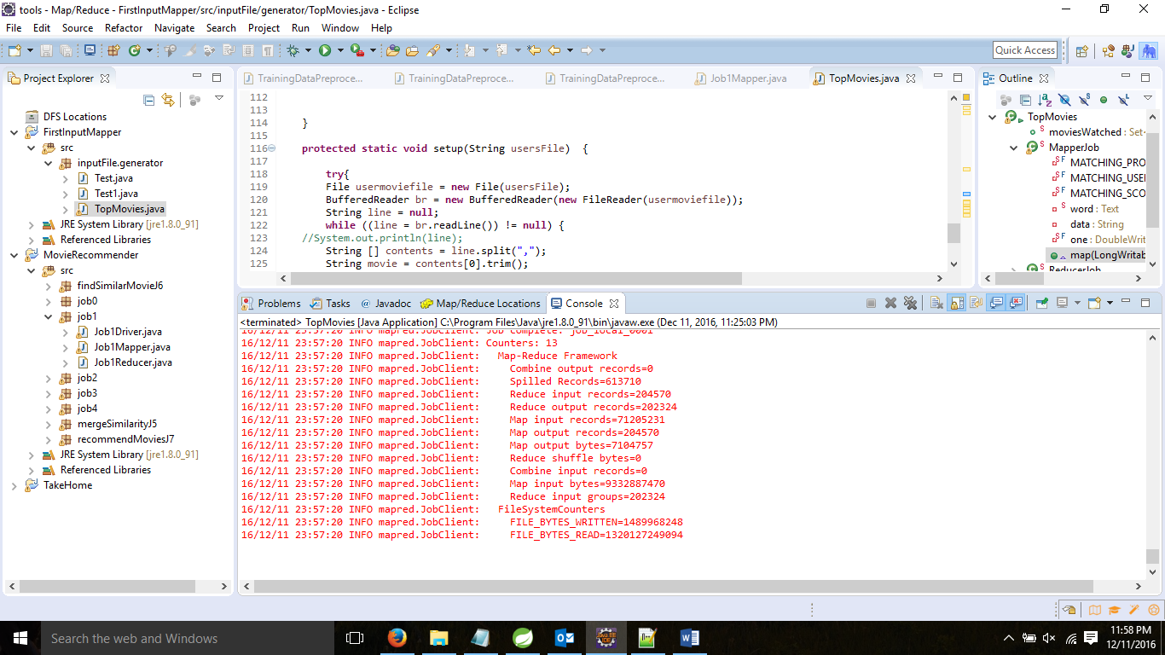

**Job 0:**

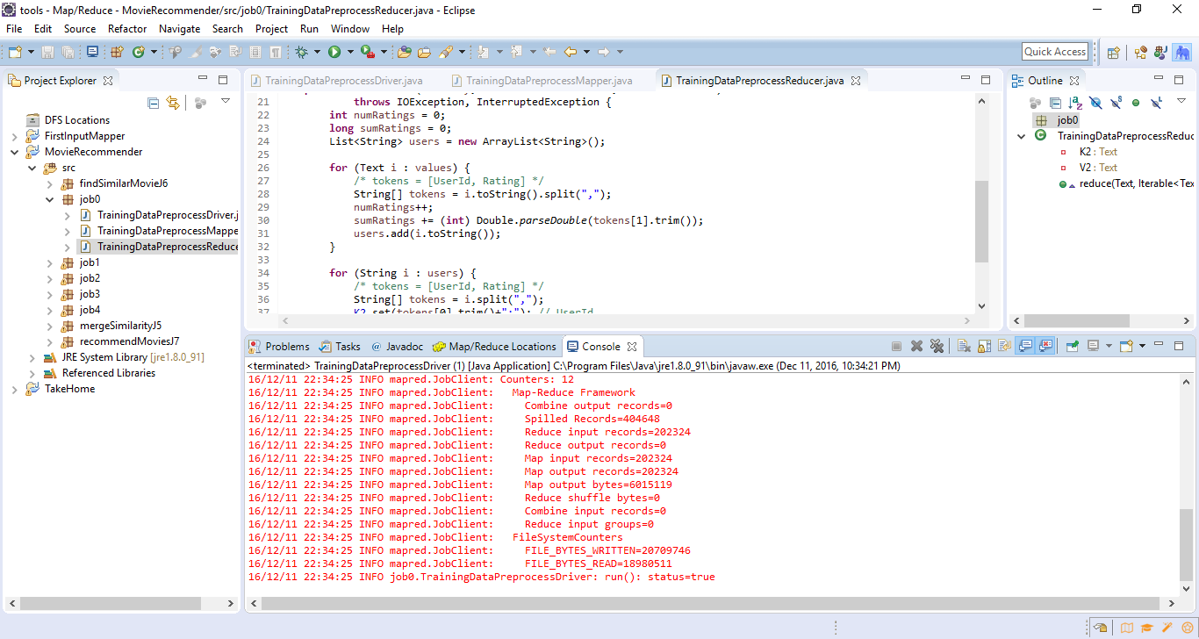

Job 1:

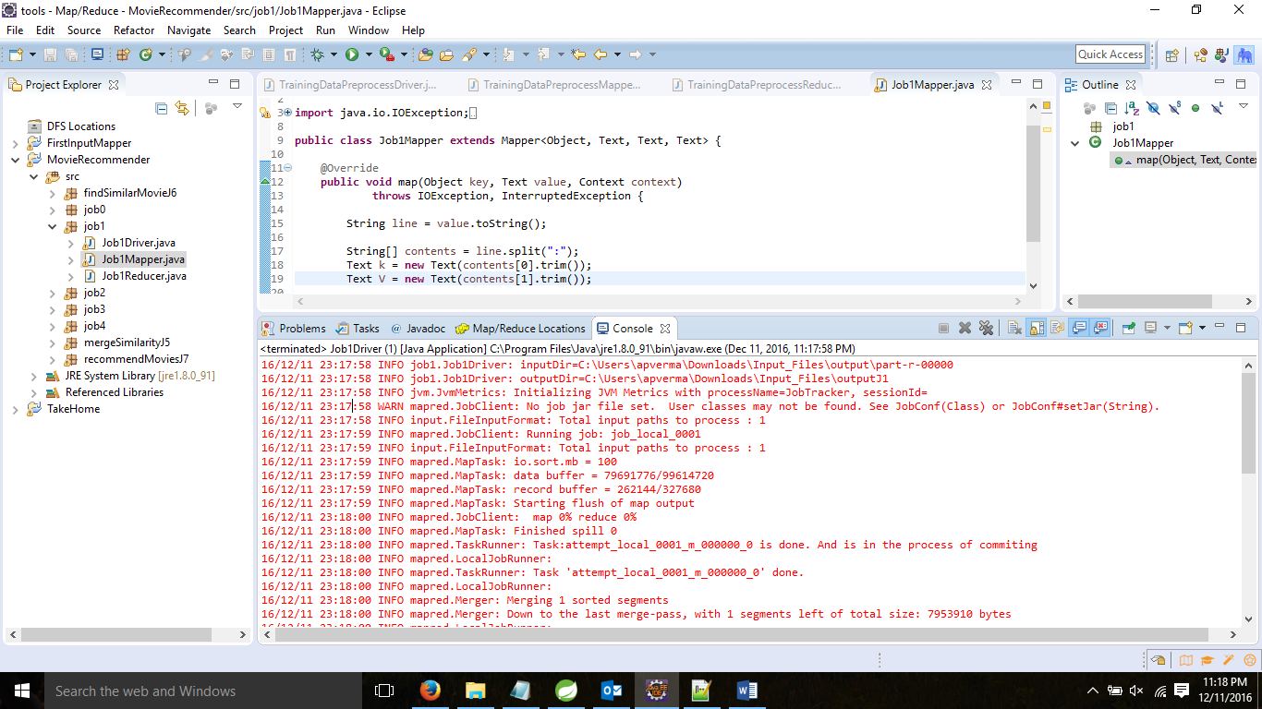

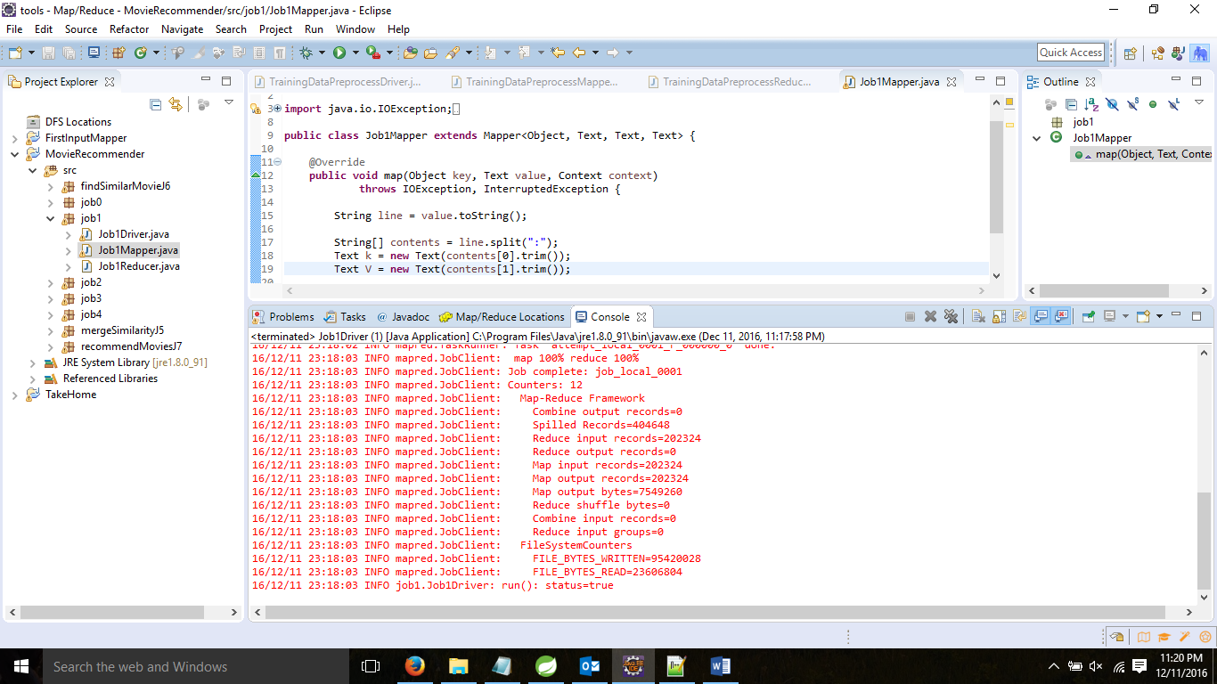

Job 2:

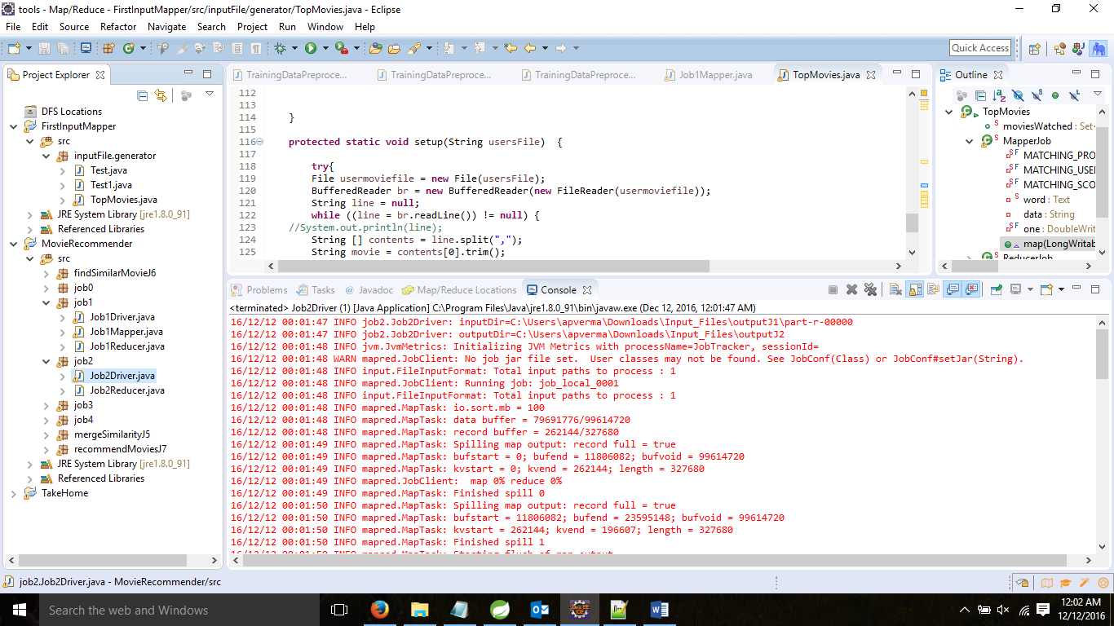

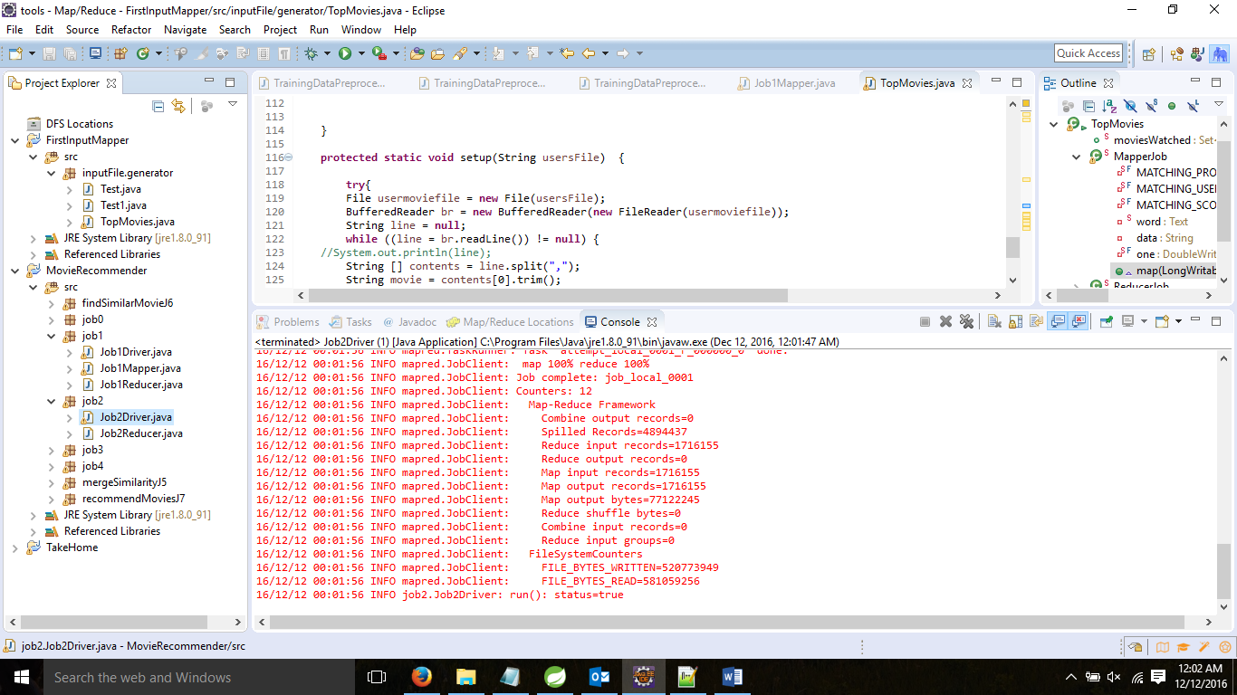

Job 3:

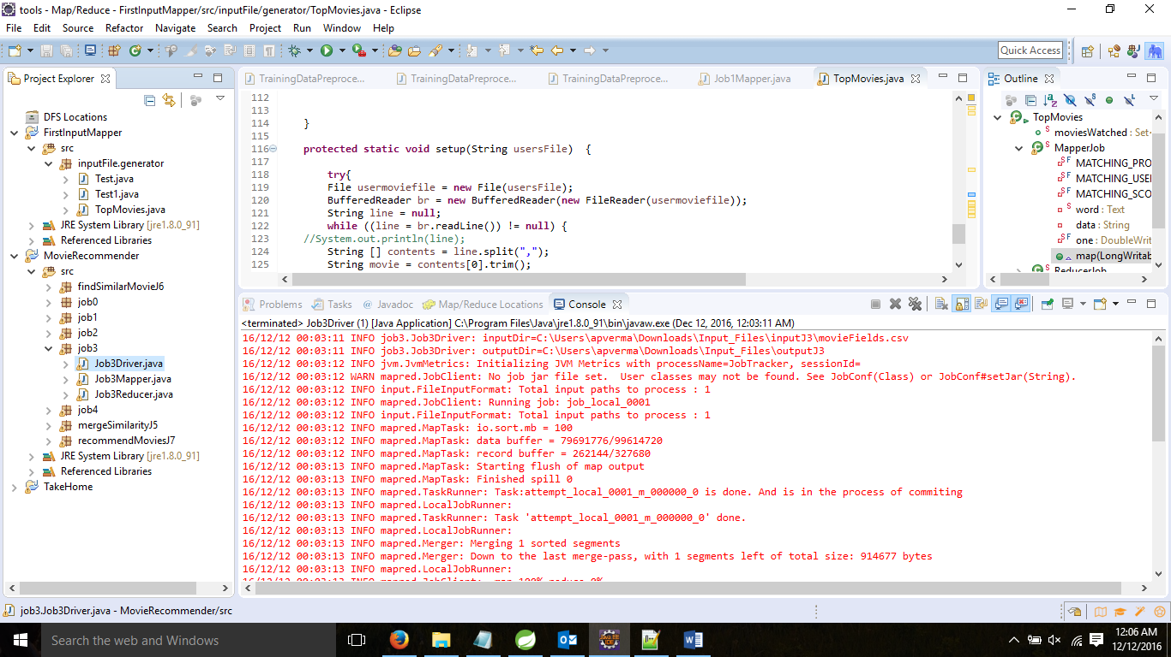

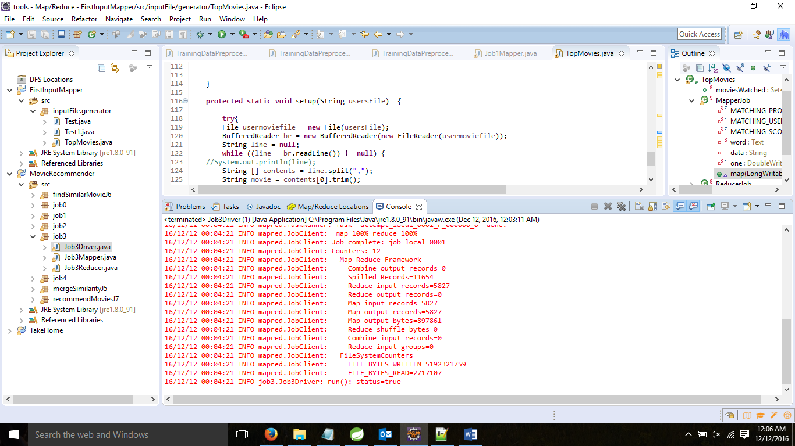

Job 4:

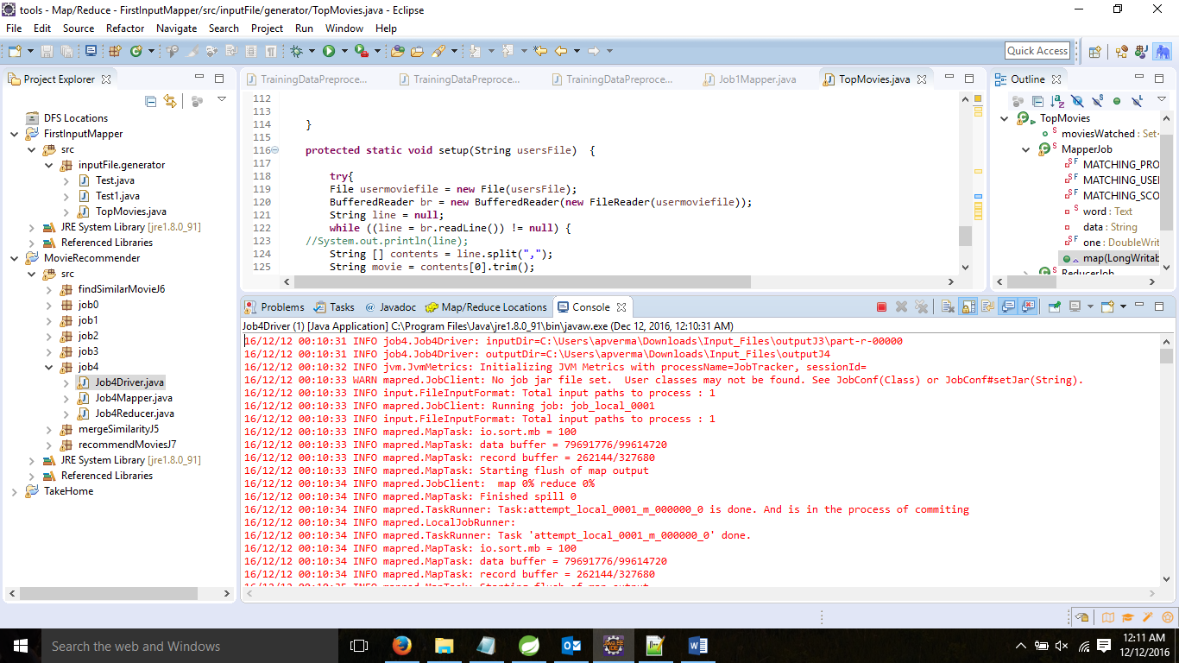

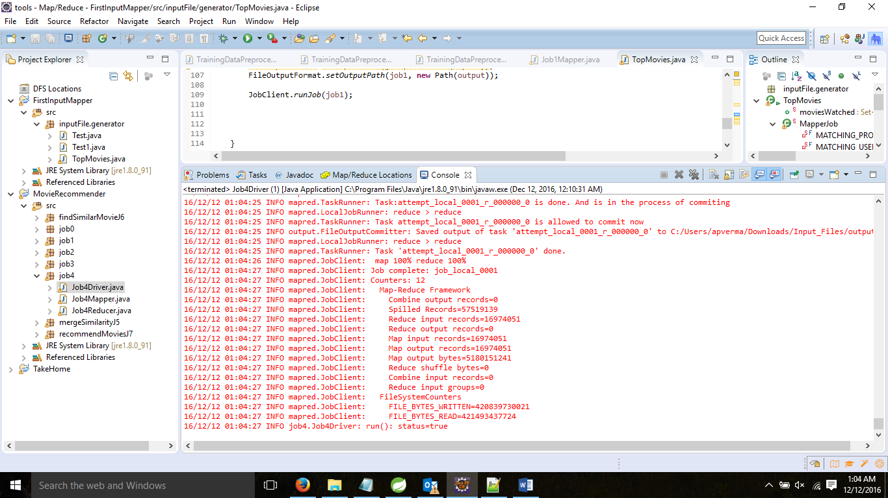

Job 5(mergeSimilarity):

Expected Result : Merge the similarity of movies based on the individual users rating and movies-movies similarity using other movie attributes.

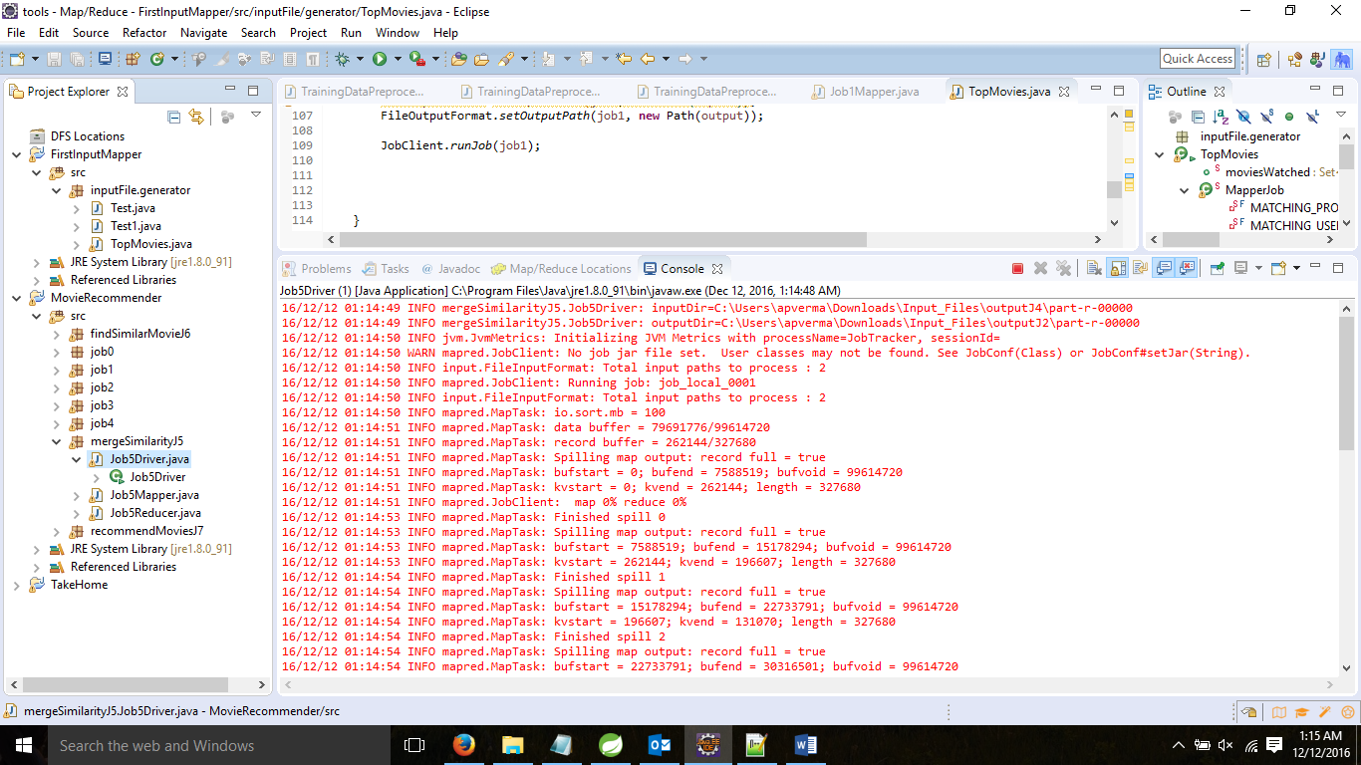

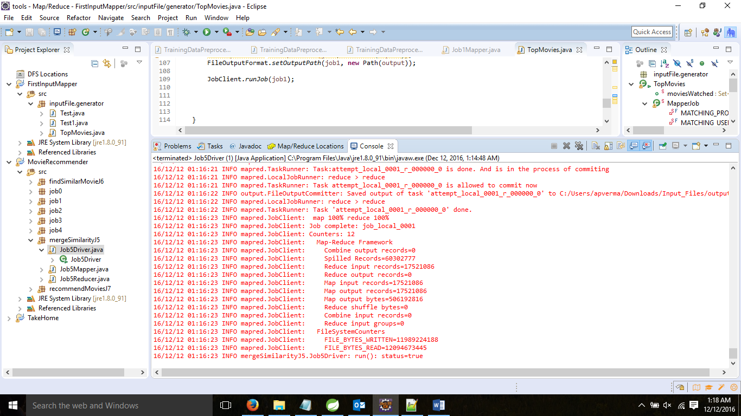

Job 6(findSimilarMovies):

Expected Result : Based on the similarity score find top 10 similar movies for every movie.

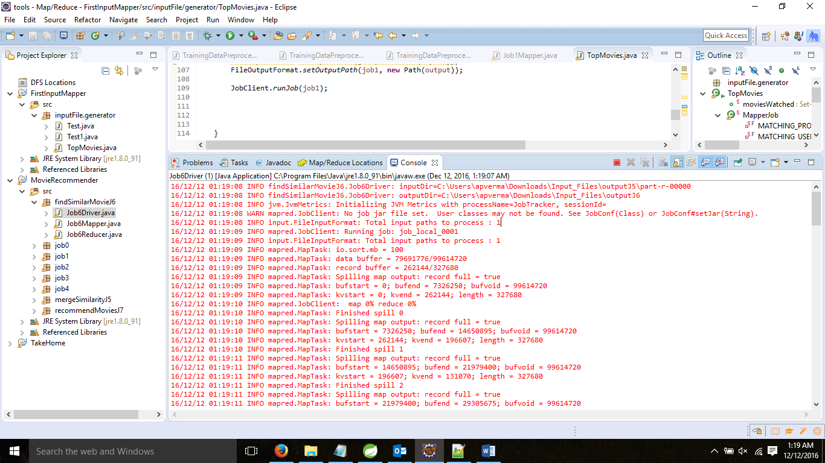

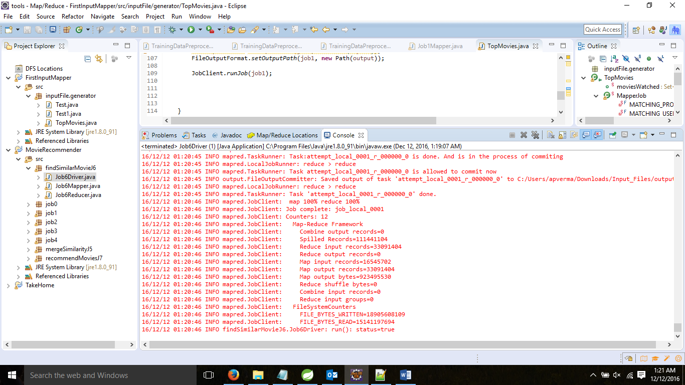

Job 7(RecommendMoviesForUser):

Expected Result: Based on the similar movies from previous job we can recommend movie to a user. Finds the movies watched by user and takes their rating in a list, for every watched movie this job finds 10 similar movies and weight their similarity score with the rating he gave. After this it returns top 10 movies from this whole set.

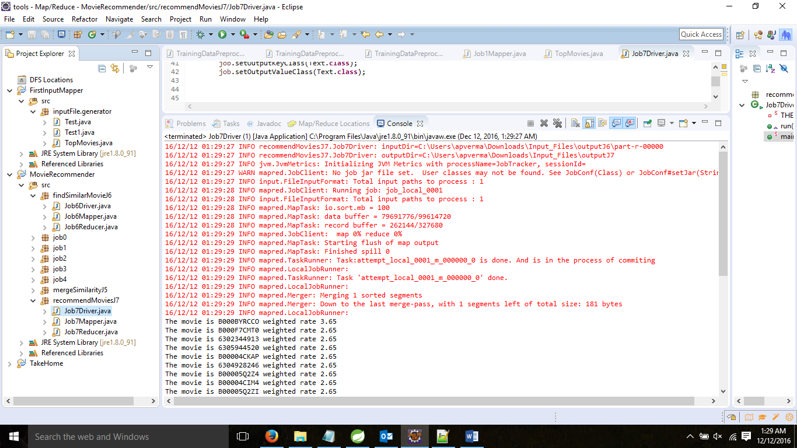

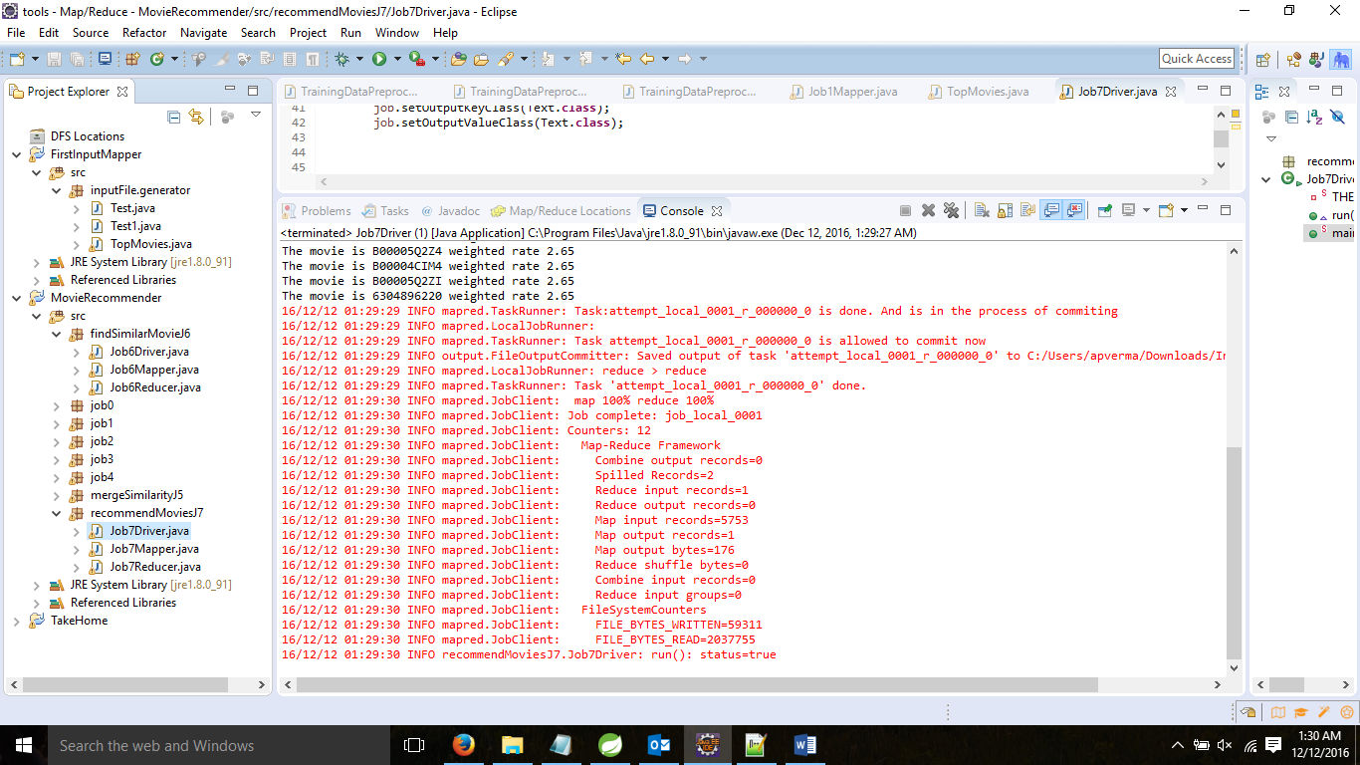

We have provided the pig scripts in the project submission folder. We have analyzed the output data from the map reduce jobs through the PIG Scripts and store the output to the My SQL database for storing and displaying the contents through web application.

Some of the Analysis done through PIG are:

* Top 5 movies by genre: like Comedy, Horror, Romance, Thriller and Sci-Fi.
* Analyzing the frequency of movies and average duration of movies in a gap of 10 years.
* Distribution of ratings for various Genres: like Comedy, Horror, Romance, Thriller and Sci-Fi.

We have used Microsoft azure to analyze the dataset for Ratings prediction for each movies input. We have achieved mean absolute error .26 and accuracy approx. 0.71. We have used the following Machine learning algorithms for prediction.

* Bayesians Linear Regression
* Boosted decision Tree
* Neural Networks
* Linear Regression

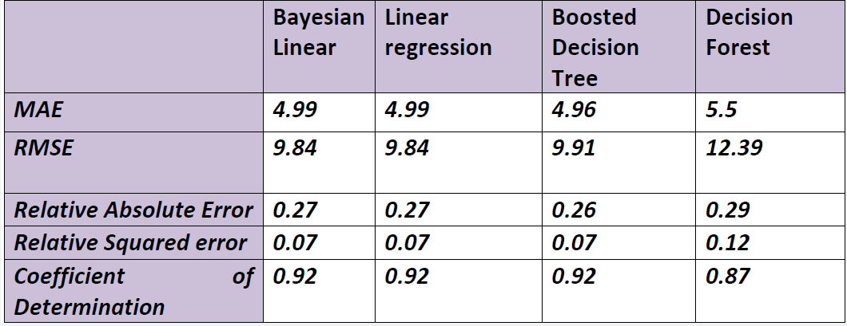

**1. Bayesians Linear Regression**

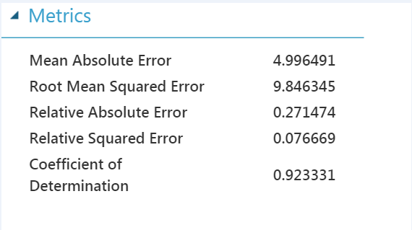

**2.Boosted Decision Tree**

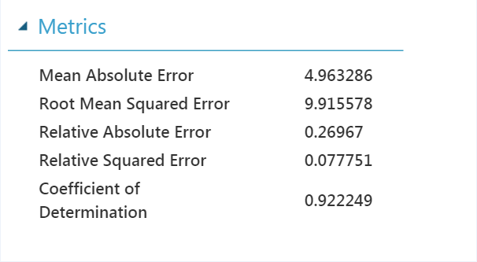

**3. Decision Forest**

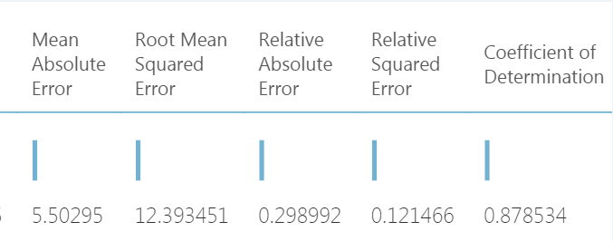

**4. Linear Regression**

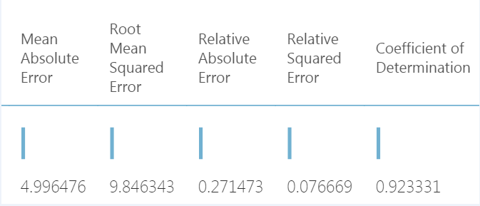

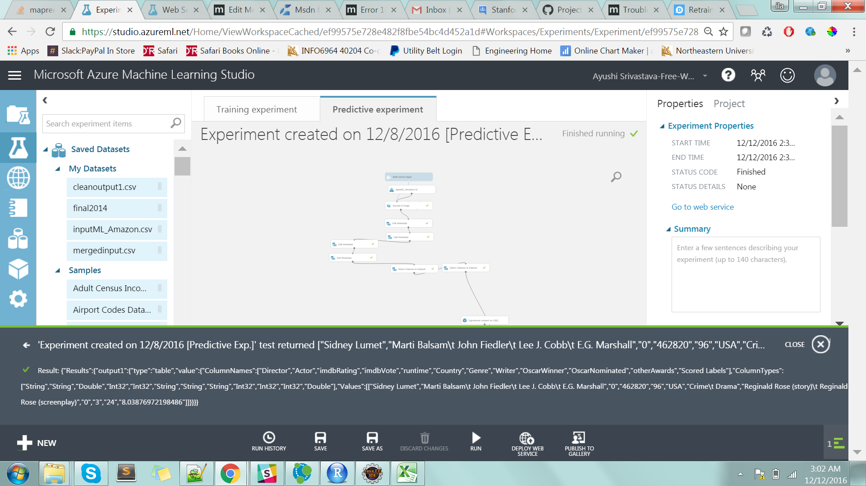

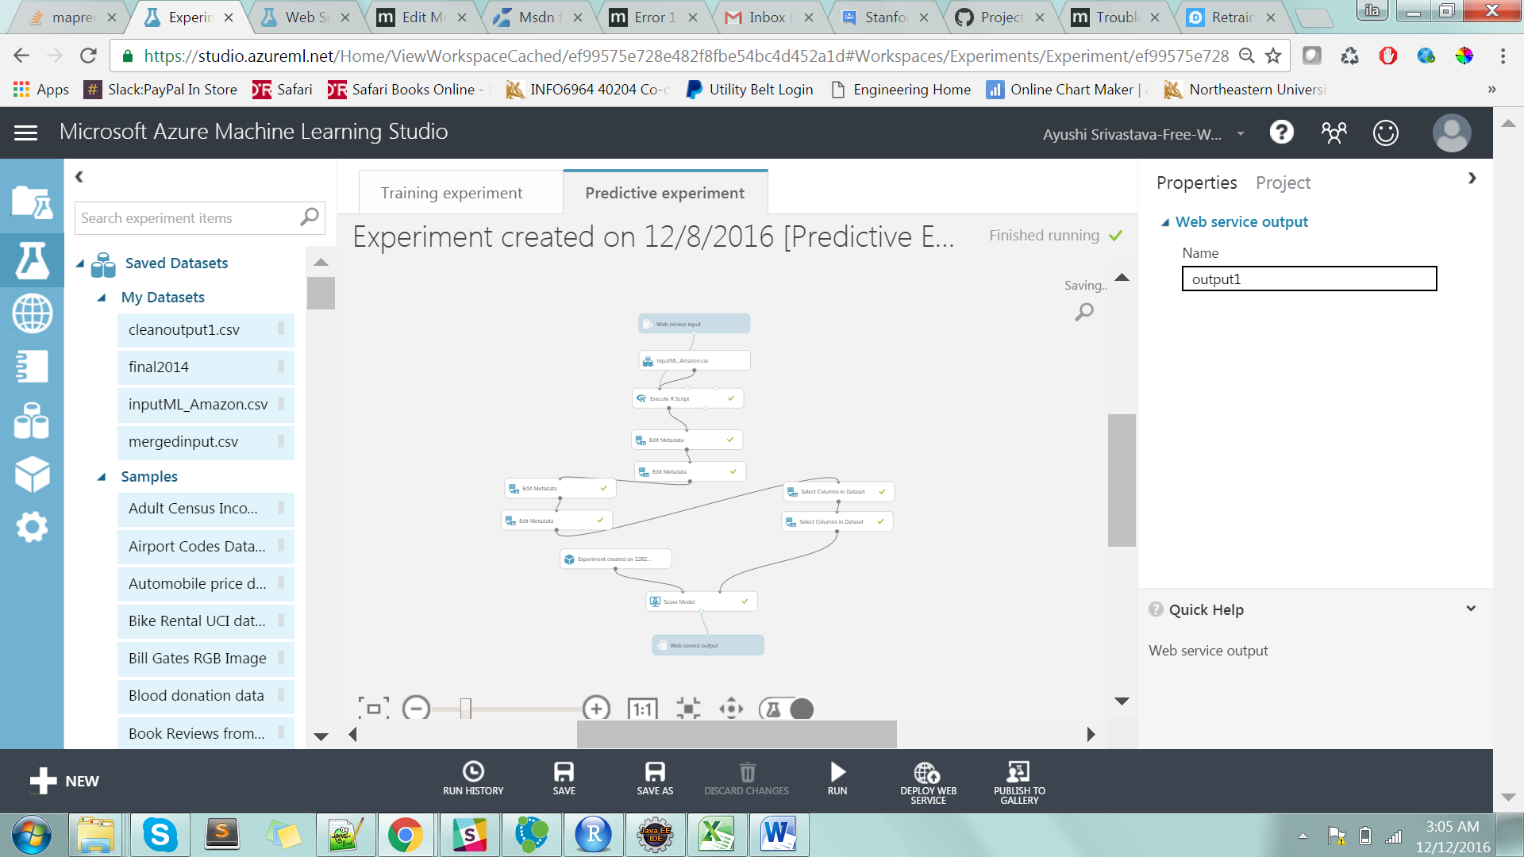

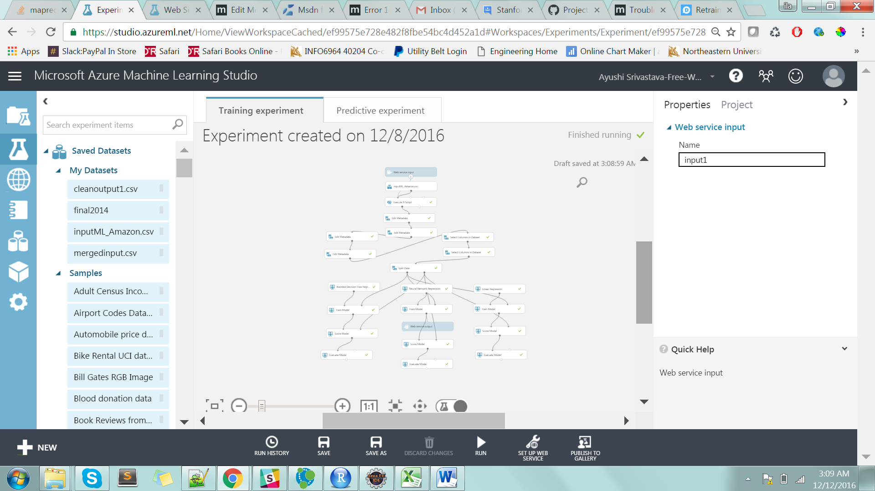

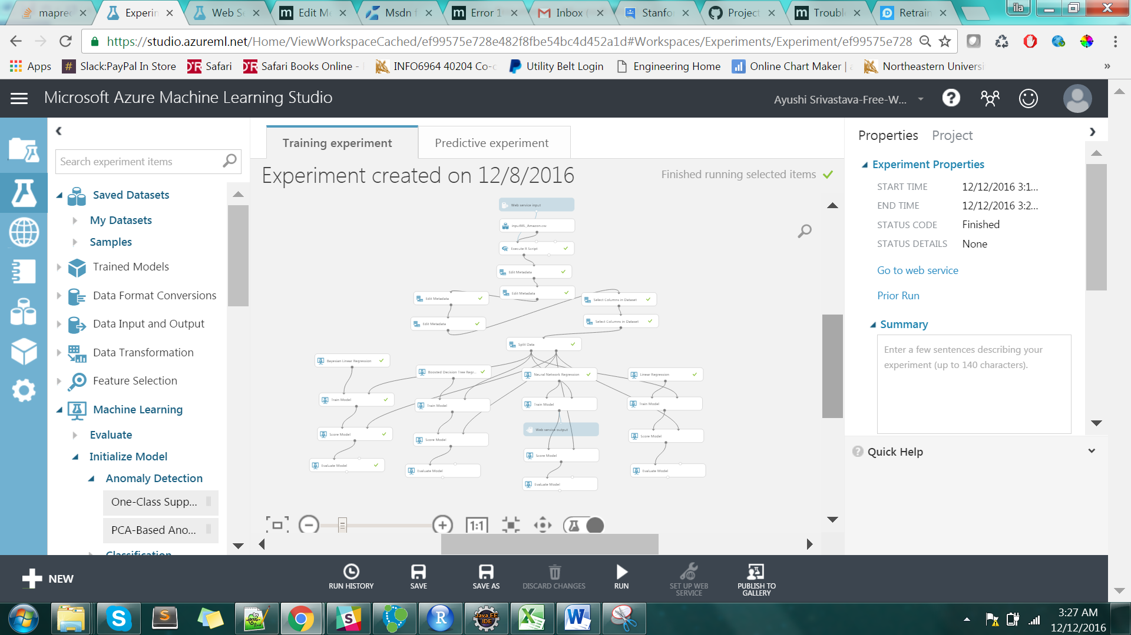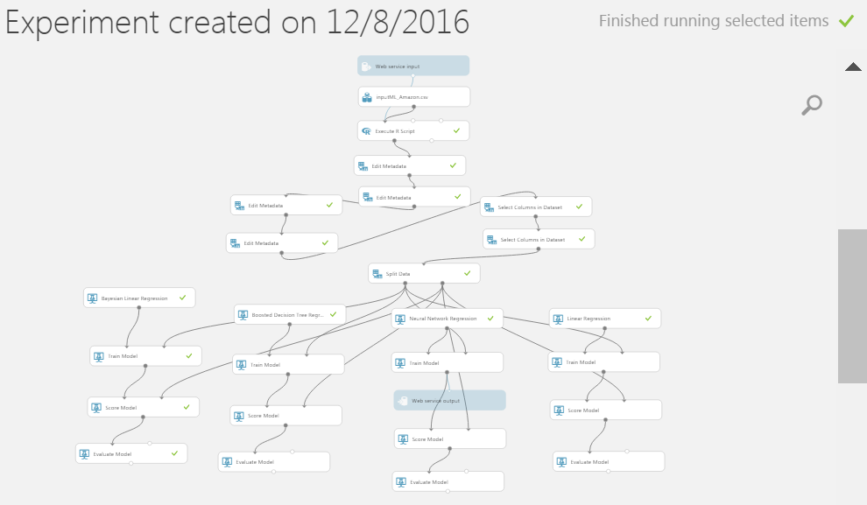

**Data Analysis Using PIG**

We have used PIG to analyze the dataset and displayed the results on the web application by storing those results into database. We have also plotted graphs to visually depict the analysis.

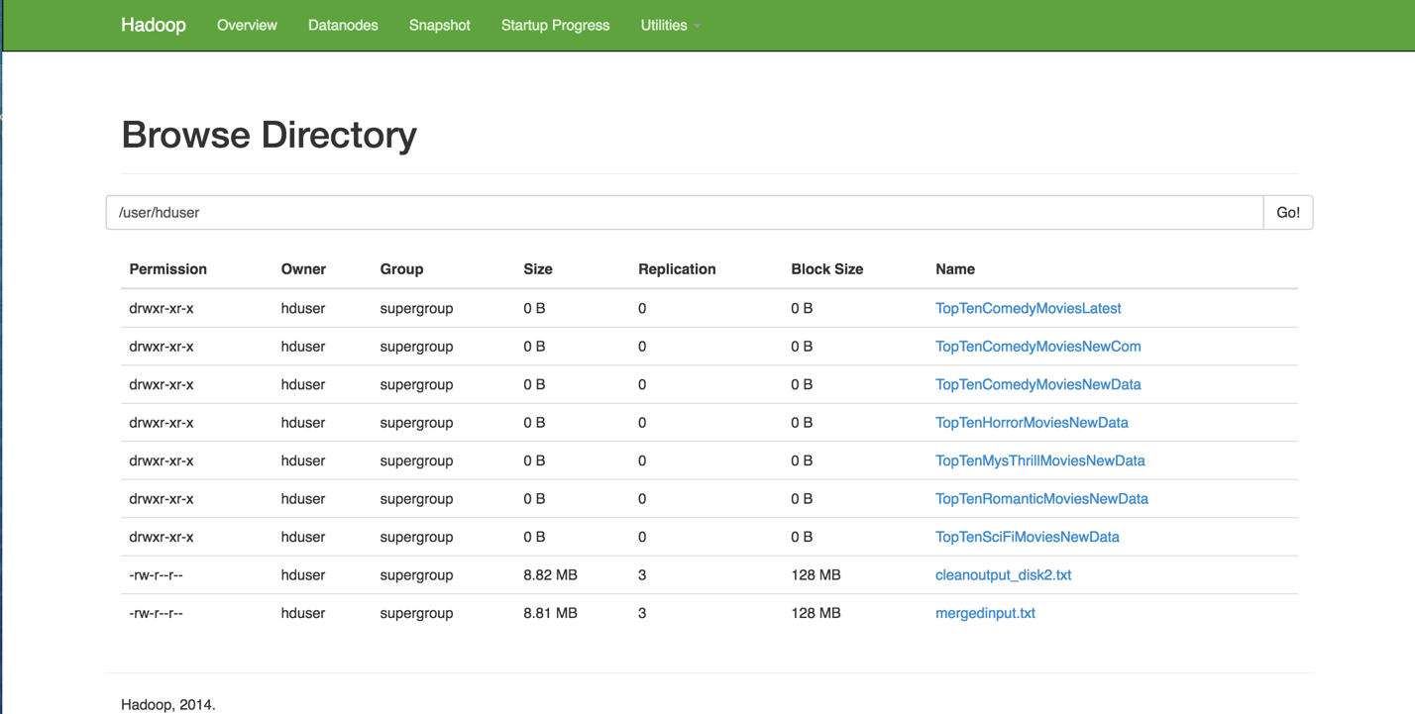

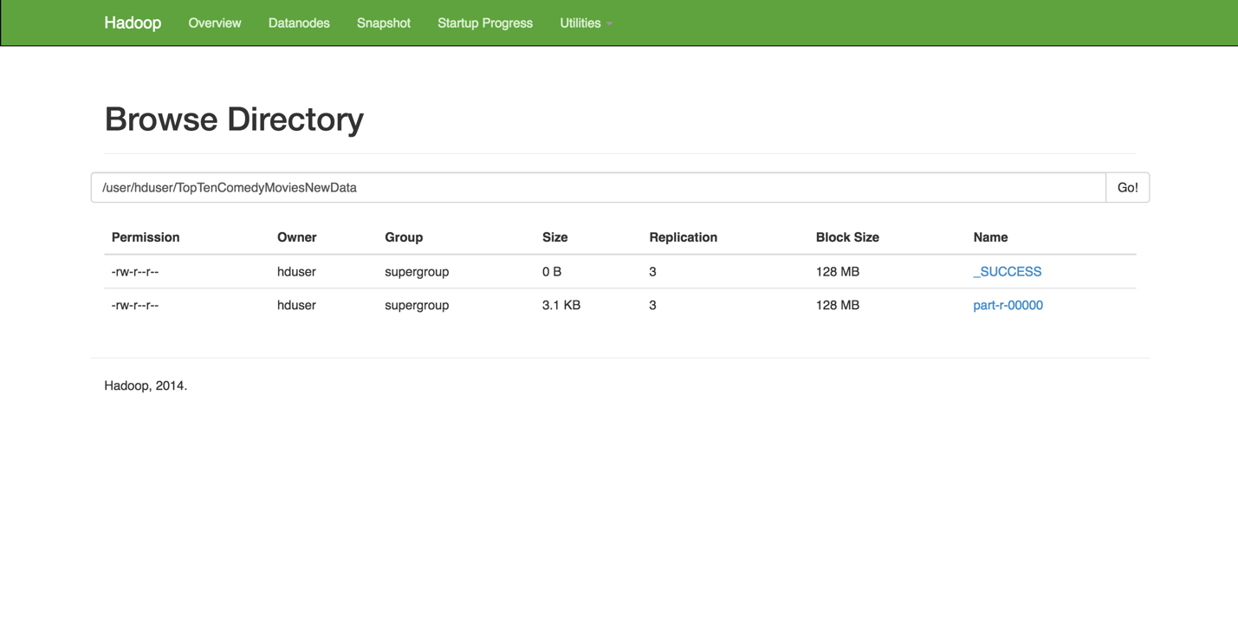

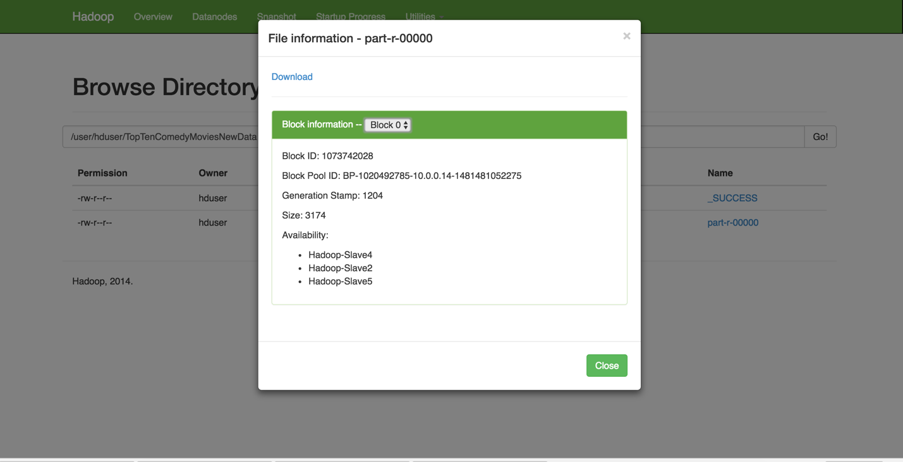

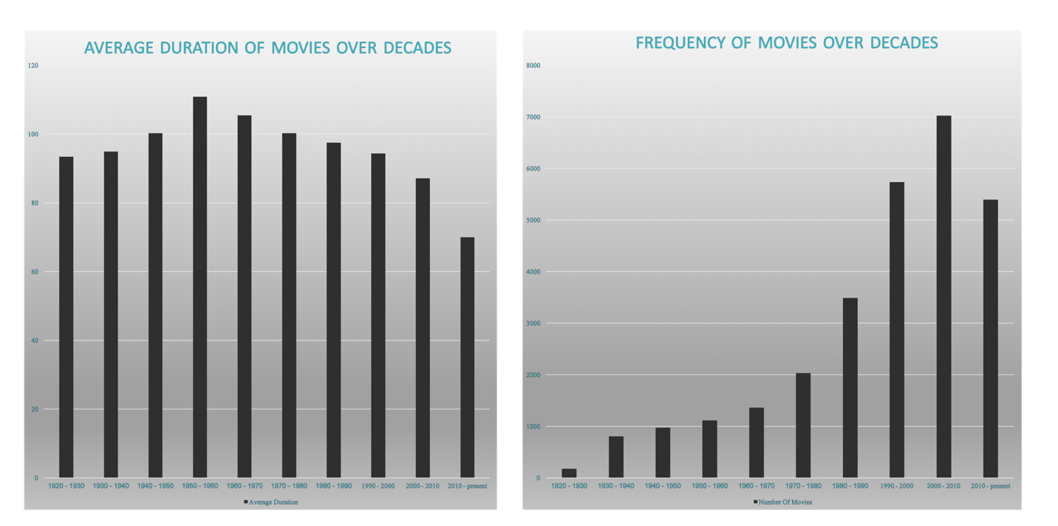

**Visualizations Using Tableau Server**

We have used map reduce jobs output’s that combines the outputs of the Amazon movie reviews and OMDB API for analyzing the movies as per various categories.

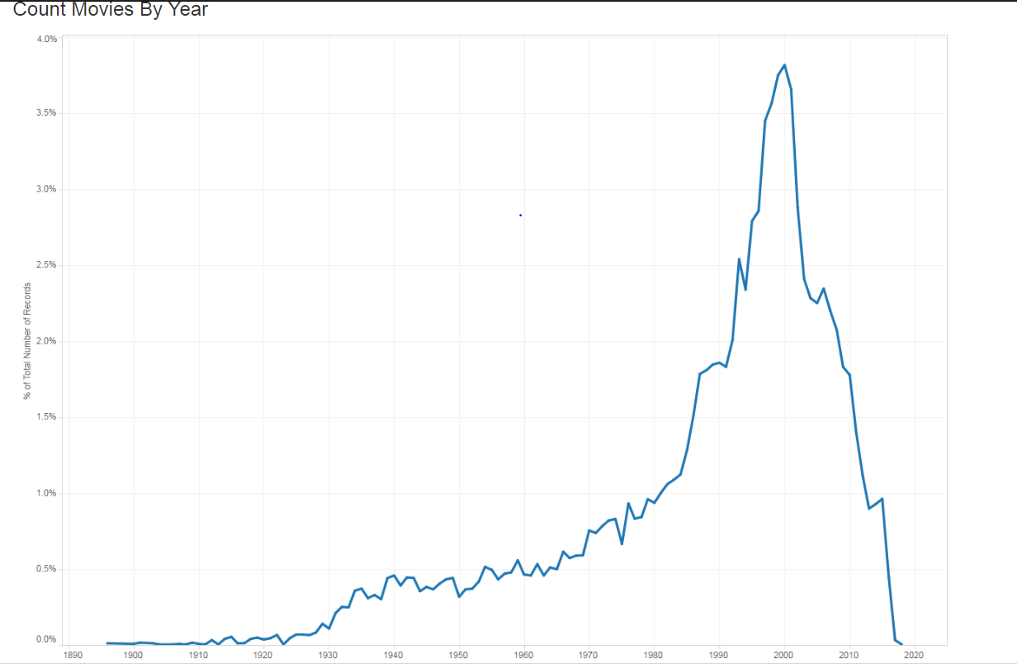

Rating Distribution

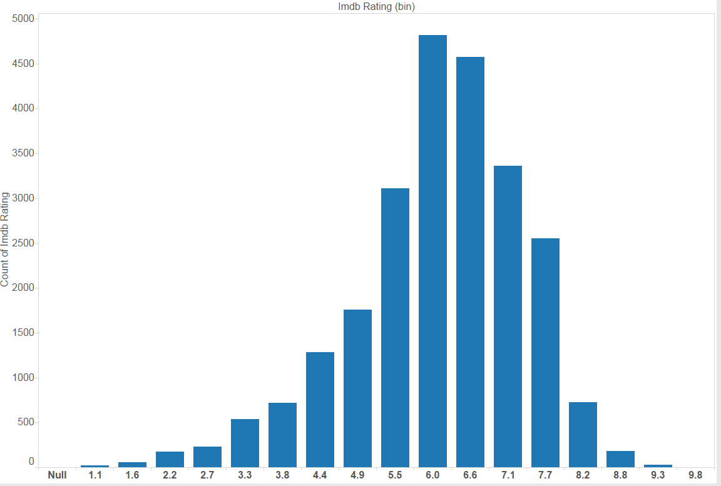

Gantt Chart by Genre and Year

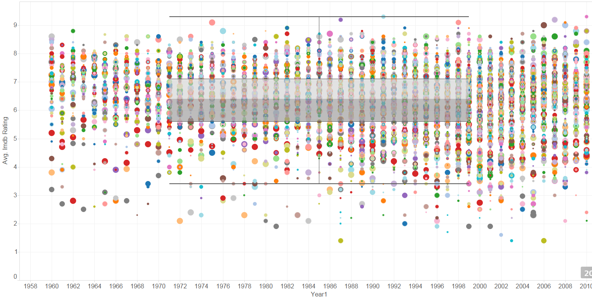

Oscar awards and other awards

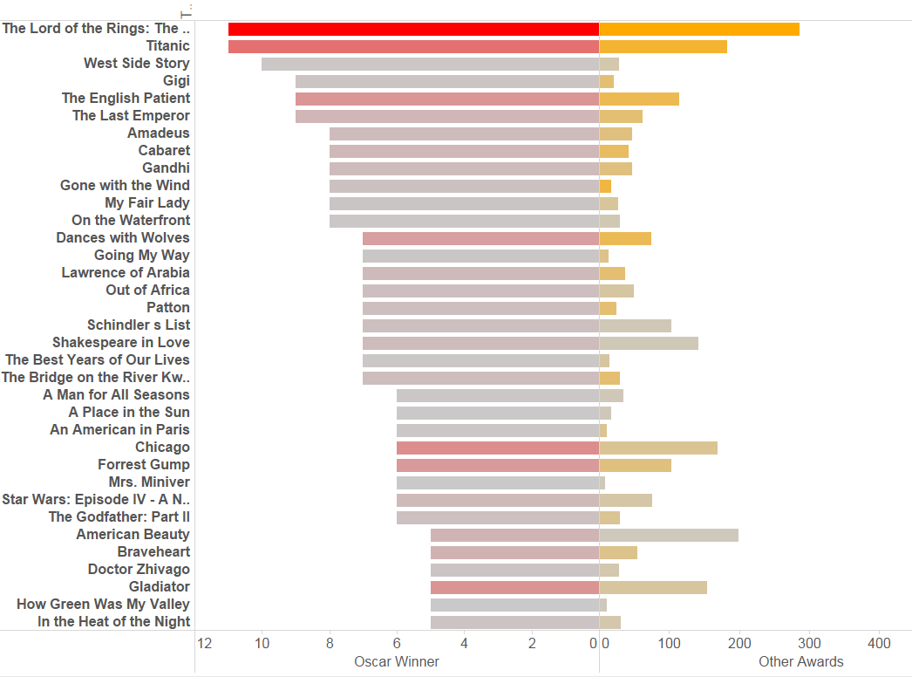

Imdb votes

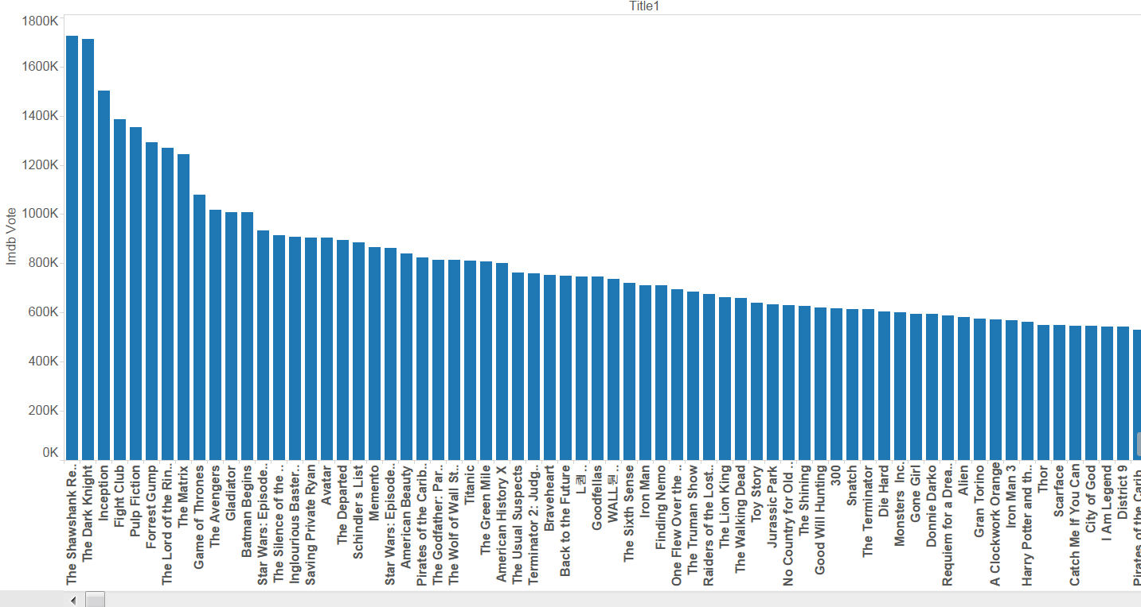

**Application Screenshots**

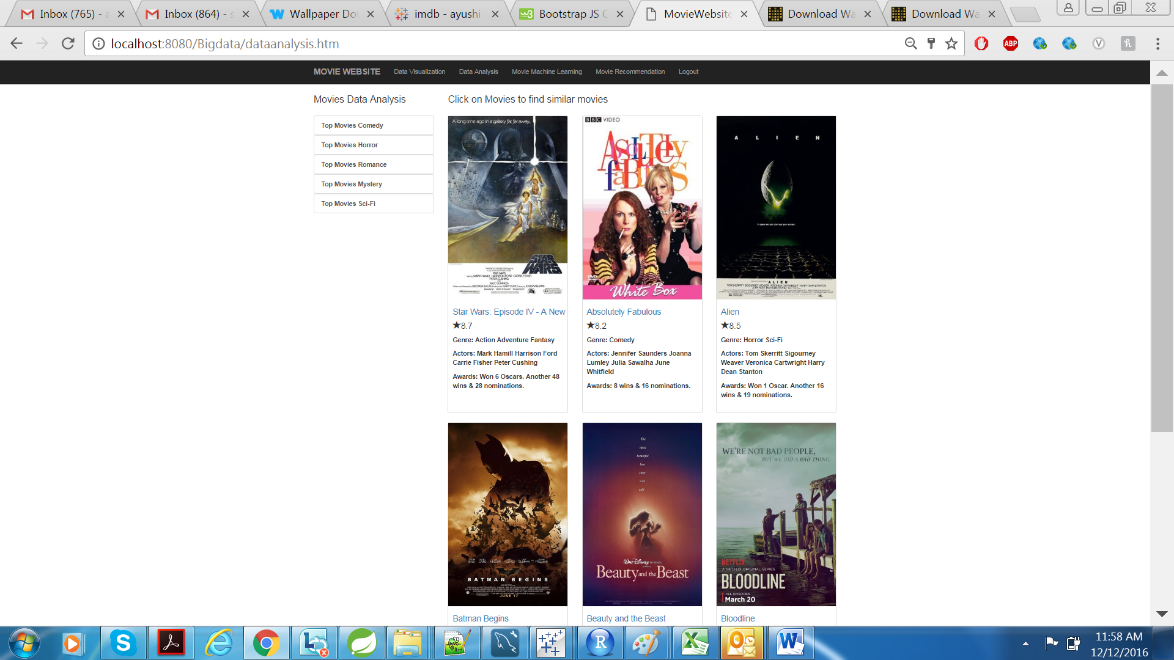

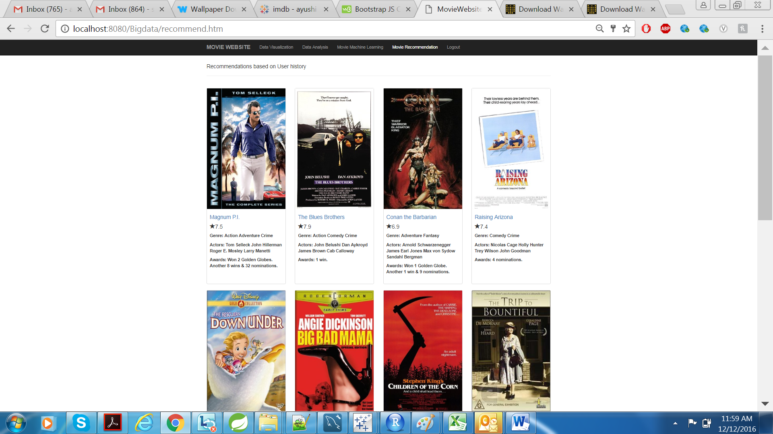

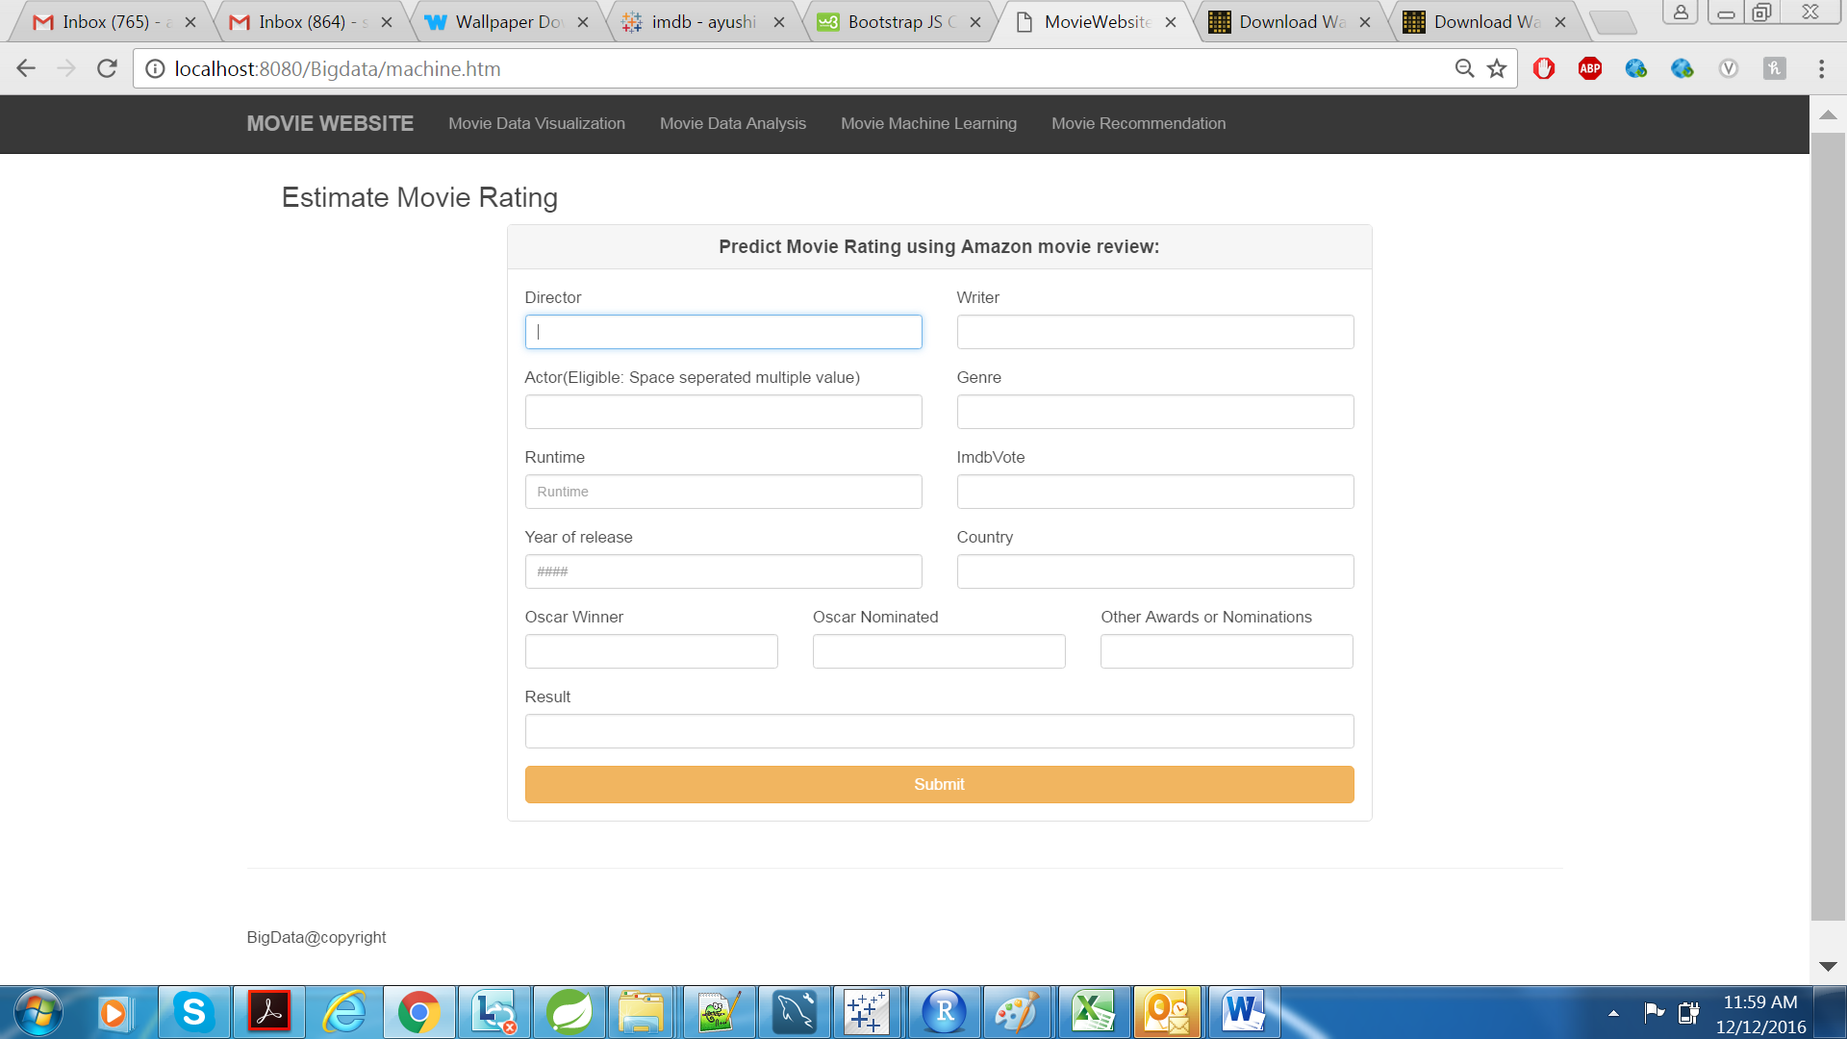

**Contribution by Each Individual**

As a team we have worked effectively on all areas of the project somehow and helped each other in case of issues and concerns. As some of the functionalities are dependent to each other we have to schedule and allot the tasks sequentially.

**Ayushi Srivastava:** She is responsible for creating the web application that is actually responsible to handle the user session and creating the visualizations using Tableau for the top movies based on the many categories. Many pig scripts and integrations are developed by her. She is responsible for data analytics and movie ratings prediction using the Microsoft Azure.

**Gaurav Saxena:** He is responsible for developing the recommender based on the Amazon movie data. He has used Mahout Library first to recommend the movies using the Amazon movie dataset but after that he build the custom Map reduce jobs to handle and generate the recommendations using users and items.

**Ila Nigam:** She is responsible for handling the Amazon Movie review large dataset using map reduce jobs and combining the analysis using the OMDB API dataset. The output file contains items values and other attributes combined using the two API’s. She is also responsible for developing sentiment analysis of the Amazon movie reviews.

**Ruchi Gupta:** She is responsible for building the PIG Scripts and analyzing the data for the web application and other visualizations. She developed map reduce job to calculate the average ratings per user for the Amazon review dataset and the OMDB API.

**Issues and their Resolution**

* We faced many issues related to the API call’s as we need to parse the Amazon movie datasets using the Amazon Id and then we need to call OMDB API for all those movies are retrieved from the API. As the API’s response is slow and for many movies we are not getting the response. We actually needed more time to retrieve all details from the data. We resolved this issue by first changed the parsing map reduce job that is actually selecting the cleaned output and then with title we are calling the OMDB API. Then we need to run the Map reduce job parallel to retrieve all the movie details.
* For recommending the movies to the Users using mahout recommendation library we are facing issues in parsing the input file as the input file needs to be converted from alphanumeric values such as Amazon Id and Movie Id to Integer or number values. But as we have decided to build our own recommender Map reduce Jobs. We have not used Mahout Recommendation library.
* For using pig and installing pig we have faced issues as the version of Hadoop is not supported with the pig we have installed. Then after installing the PIG we have faced issues in configuring it. After lot of efforts we are able to resolve the configuration issues by installing the correct versions and reading the correct documentations for configurations.
* The main challenges for this project went into data enhancement and preprocessing so that the data will be readily available for the user who uses our web interface. The major problems faced were in the crawling part where we had to correctly adhere to the politeness policy as the calls were going in parallel. Also, the OMDB site was unstable and we had to crawl multiple times to get all the movie details.

**Conclusion/Results**

We are able to recommend the user based on the previous User ratings and also item based similarity and recommendations. We have not used any built in libraries for the prediction like Mahout that contains already the Machine Learning and Map reduce algorithm for user based recommendations. We have successfully able to predict the movies ratings based on the previous ratings and scores. For that we have developed the data model based on machine learning algorithms for prediction. At Last we have also used the Map reduce for Sentiment analysis of the Amazon Movie review dataset. We have provided the user interface for traversing and viewing the movie recommendations as per the user ratings. Also it is capable of showing all the visualizations using tableau server based on various categories. We have used Microsoft Azure for movie ratings prediction using machine learning algorithms.

**Future Scope**

Future enhancement for this project could be to do a real time data analytics of the movie API as we have used the dataset of the Amazon Movie Review datasets. Also we are recommending the users based on the user and item recommendations. But as we have to run the map reduce jobs already and store the data in the database for movie we have to real time recommend the user who is logged in based on the inputs that he has provided to the questions that is being asked relevant to its taste or choice of movies.

We have not used Amazon EMR for the Map Reduce jobs as it is far more flexible, effective and scalable to run the application in it.